Manager Essentials:
Addressing Conflict on the Floor


Leading Through Conflict
Today’s objective:
Handle conflict productively to meet business objectives and maintain relationships.

What is Conflict?
What is the first word you think of when you hear “Conflict?”

Productive Conflict Defined:

DISC Style Priorities in Conflict

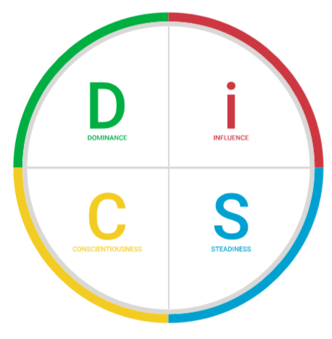

Recognizing Destructive Responses

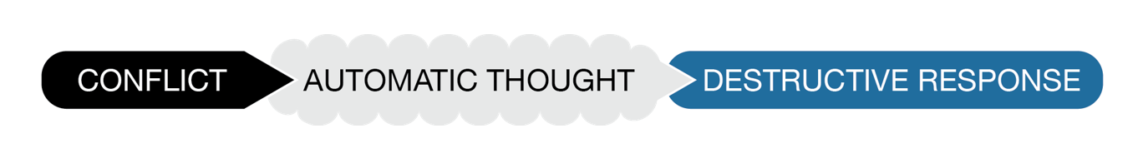
Activity:
Think of a conflict situation that did NOT go well. Check any of the responses that are YOUR natural destructive response(s) in conflict.
- Arguing  - Belittling  - Caving in  - Defensiveness  - Diminishing others’ opinions  - Becoming overly dramatic  - Exaggerating the problem  - Exclusion/leaving people out  - Finger-pointing/blaming | - Gossiping/complaining about someone  - Becoming hypercritical  - Overpowering  - Passive-aggression  - Revenge/looking to even the score  - Sabotage/introducing obstacles  - Sarcasm  - Stonewalling/becoming non-receptive  - Withdrawing

Recognizing Destructive Responses
After sharing your situation, discuss with your partner:
- Why do you engage in this behavior?

- How do you think this behavior affects others?

Conflict Behavior Approach (the WHY)

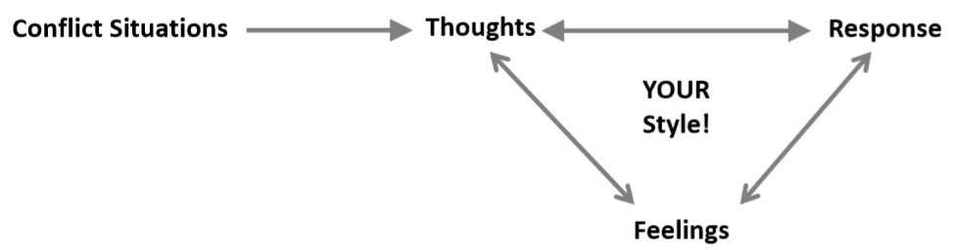

Changing My Response
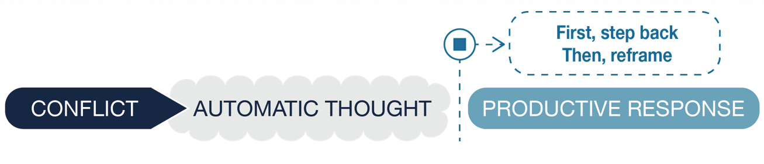


Stepping Back:
What makes stepping back difficult for you?

What would help make you more successful?

Reframing Your Automatic Thoughts
My automatic thought:

Do I know with 100% certainty that this thought is actually valid/true?

Am I overreacting or exaggerating?

Is there another way to look at this?

My reframed thought:

_____________________________________________________________________________________
My automatic thought:

Do I know with 100% certainty that this thought is actually valid/true?

Am I overreacting or exaggerating?

Is there another way to look at this?

My reframed thought:

Choosing Productive Responses

Response | Easy Difficult | Response | Easy Difficult
Apologizing |  | Finding compromises
Determining the root  of the problem |  | Listening
Stepping back to reflect |  | Communicating openly and honestly
Taking ownership of your part in the situation |  | Separating emotions from facts
Giving people time and space |  | Showing flexibility
Acknowledging others’ feelings |  | Revisiting unresolved issues
Seeking active resolution |  | Communicating respectfully
Giving reassurance |  | Being aware of your feelings

Activity: Coaching Through Conflict

Purpose: Practice applying hit pause, reframing, and leading with questions to real-world team conflict scenarios.
Scenario:
Two employees on your team have been snapping at each other. One claims the other isn’t pulling their weight. The other feels micromanaged and disrespected. The conflict is disrupting productivity, and other team members are starting to take sides. One of the employees approaches you to complain.
Your task as the leader:
You already have the tools for navigating this effectively:
- DiSC
- SBI Feedback Model
- Leading With Questions
- Above the Line
- Stepping back/hitting pause
- Reframing
How can you leverage these tools to navigate this scenario? (Hint: You may need to use some of these tools for yourself before you step in to help your team members.)
With your partner, read the scenario and generate 3-5 ideas—including specific talking points—for how you would navigate this issue.

